|  |  |
| --- | --- |
| download | COMSATS University Islamabad, Vehari Campus Department of Computer Science |

**Class: BCS-SP22 Submission Deadline: 9 Oct 2023**

**Subject: Data Structures and Algorithms-Lab Instructor: Yasmeen Jana Max Marks: 20 Reg. No:**

**Email:** [**yasmeenjana@cuivehari.edu.pk**](mailto:yasmeenjana@cuivehari.edu.pk)

**You can ask queries related to Lab Activities on the above email.**

**Activity 1:**

Create a function to display linked list output as below:

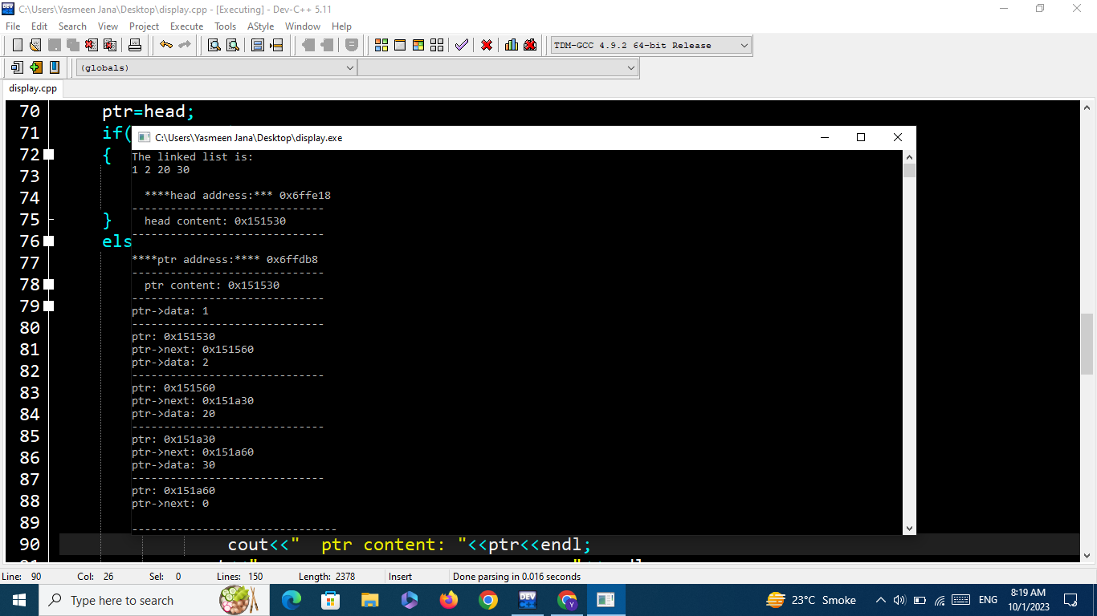

**Activity 2:**

Write a program that will implement single, doubly, and circular linked link list operations by showing a menu to the user.

The menu should be:

**Which linked list you want:**

1: Single

2: Double

3: Circular

After the option is chosen by the user:

**Which operation you want to perform:**

1: Insertion

2: Deletion

3: Display

4: Reverse

4: Seek

5: Exit

**Let's suppose, the user has chosen the insertion option then the following menu should be displayed:**

1: insertion at beginning

2: insertion at end

3: insertion at the specific data node

A sample output screenshot is below:

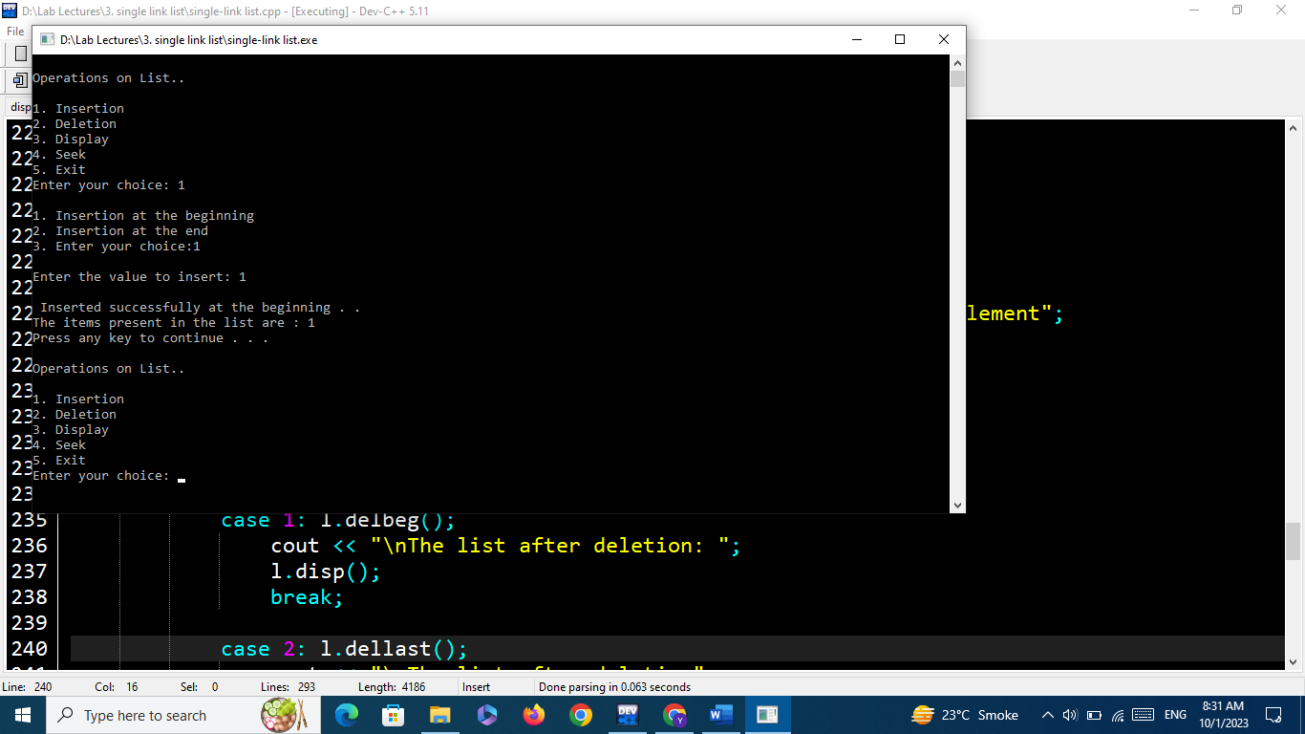

**You can get help from the below link:**

[**https://github.com/programming-debug/Data-Structure-Lab/blob/main/Lab3/single-link%20list.cpp**](https://github.com/programming-debug/Data-Structure-Lab/blob/main/Lab3/single-link%20list.cpp)

In this Word file, you should place the code and its output screenshot.

After completing the activities, Upload the final pdf and cpp code files to the “**DSA_Lab”** repository.